Patient Steps for Patient Portal

- Navigate to: www.orthoohio.com
- Select Patient portal on the top right.
- Select use mobile device
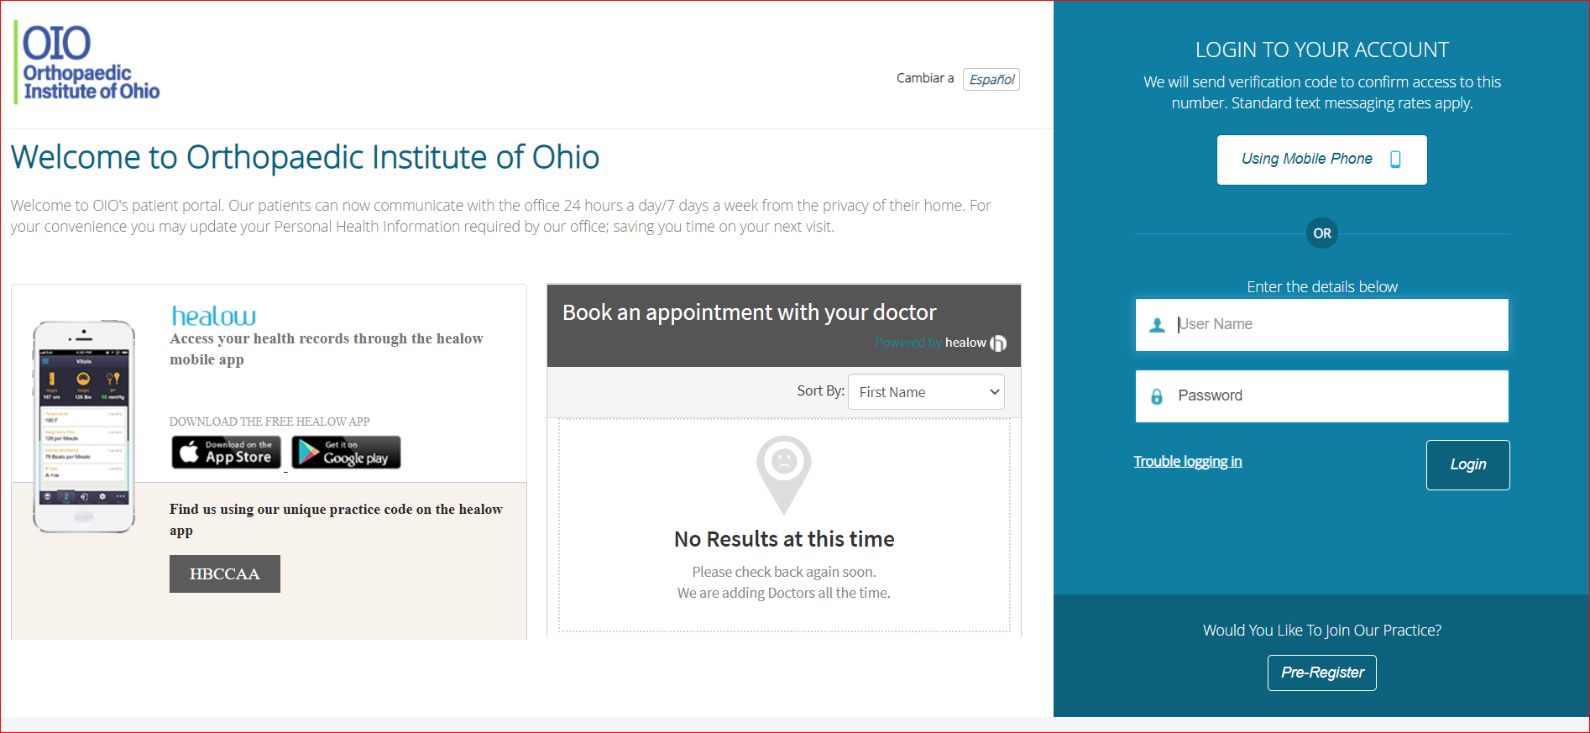

- Enter your name and date of birth. (please note: this is your full name as entered by our staff. If for some reason you receive an error you need to contact us at 419-222-6622 to speak with one of our staff to confirm we have your name spelled correctly and we have your correct DOB). Our staff will verify your identity prior to adjusting your account.
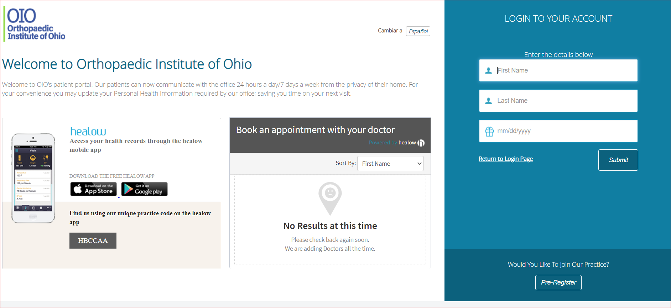

- Select the radio button of the number (cell phone) that you want to receive a text confirmation code. Select Send Code.
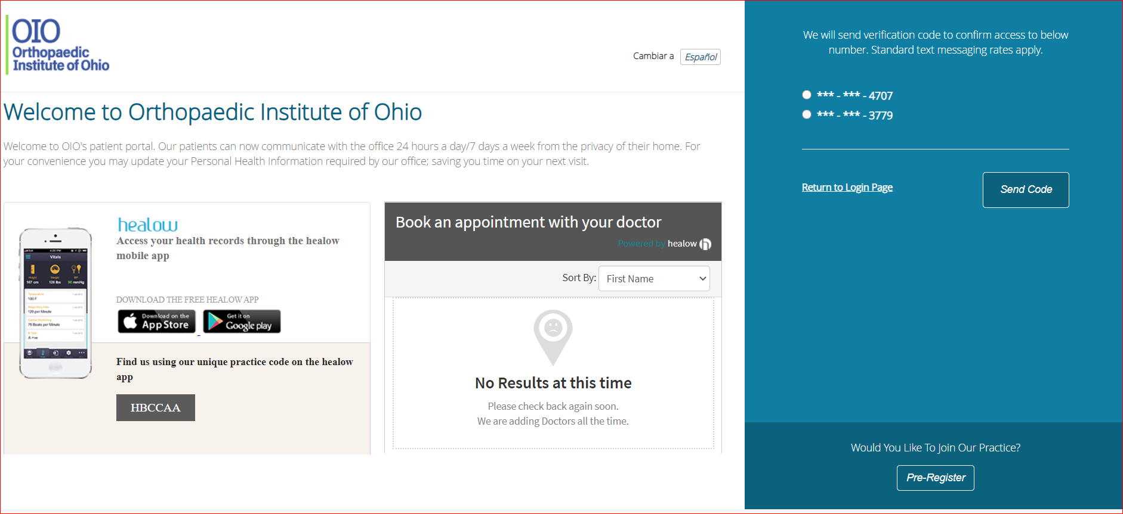

- Enter the code
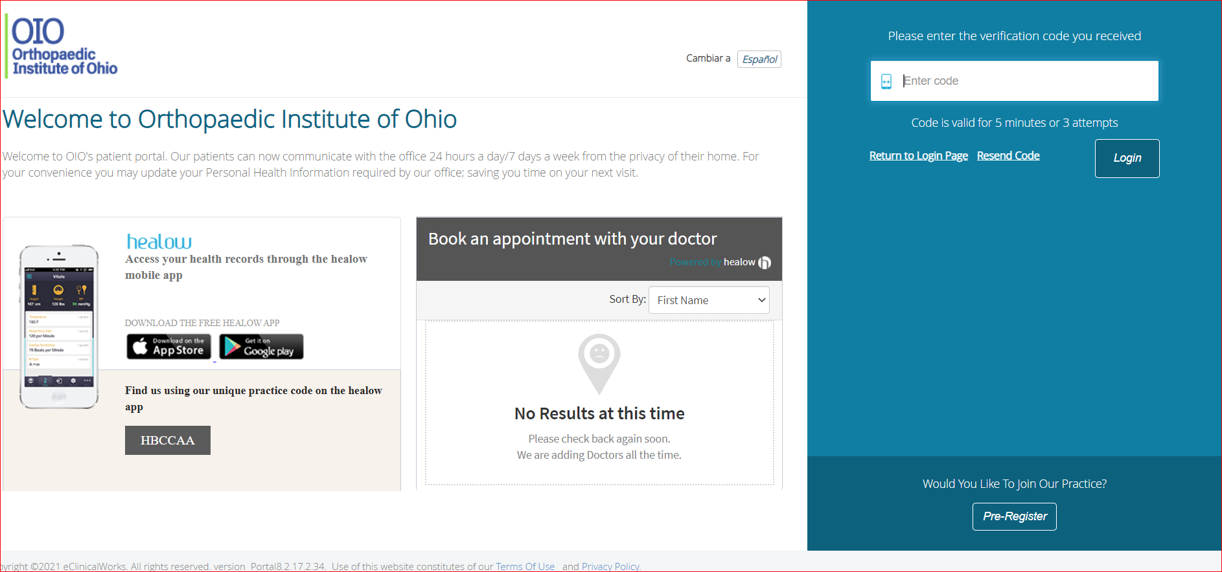

- You are now logged into your patient portal. On the right hand side you can manage your account. Select questionnaires to complete your medical history, surgical history, etc.
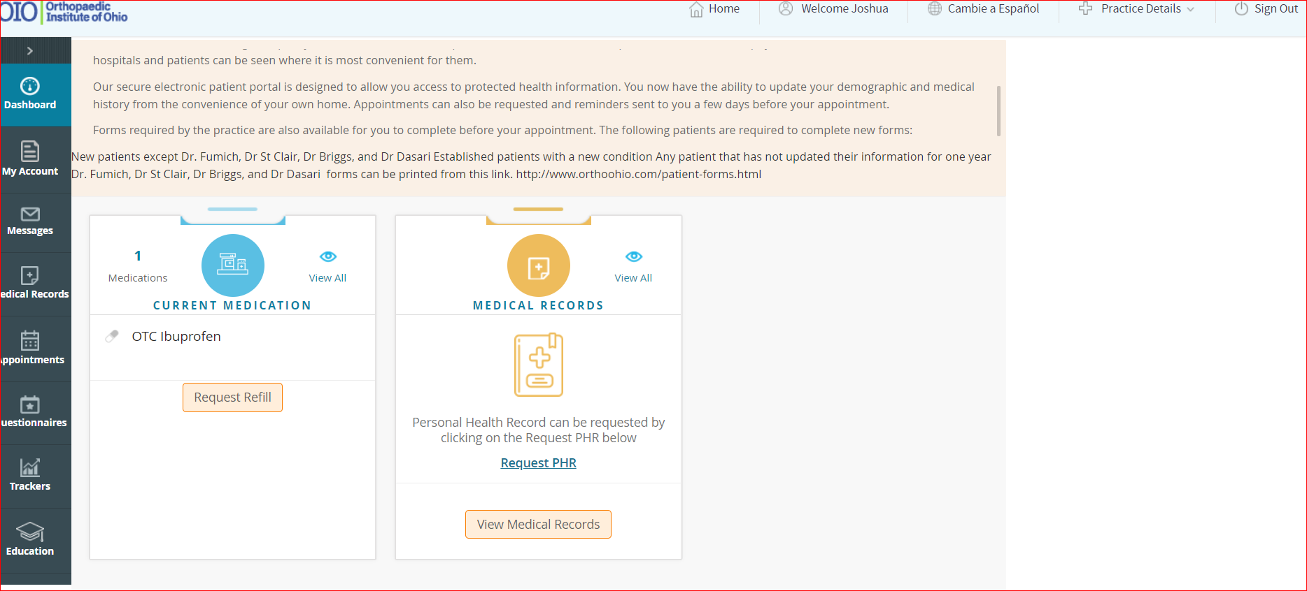
You can navigate to different sections (view visit notes, complete questionnaires, view your medical summary on the left hand side, see upcoming appointments, request refills, request an appointment, etc..

